CSIP5403

Research Methods and Applications  
Lab Sheet – 2

# Aims

* Explore examples of **expert systems** - New research on expert systems: [Expert Systems | AITopics](https://aitopics.org/search?field=taxnodes&filters=taxnodes:Technology%7CInformation%20Technology%7CArtificial%20Intelligence%7CRepresentation%20%26%20Reasoning%40%40taxnodes:%22Technology%7CInformation%20Technology%7CArtificial%20Intelligence%7CRepresentation%20%26%20Reasoning%7CExpert%20Systems%22%40%40store:Classics)
* Continue working on your **mini-project**.

# Part 1 – Expert System Examples

There are many examples of applications of **expert systems** and **knowledge-based systems**. The following tables show some examples in different fields. Research them and record your finding in an appropriate format. This task should give you the skills in doing literature review. Attempt to write your finding in a review form. The research can be done jointly in a group but the writing should be done separately.

You may wish to focus on one domain or discipline (e.g., one of the following tables):

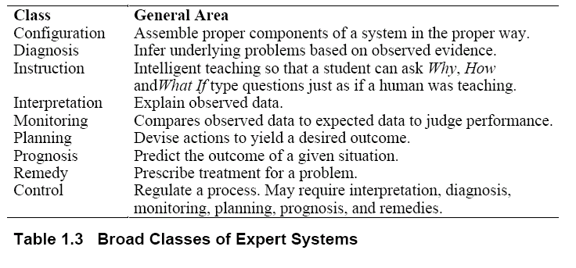

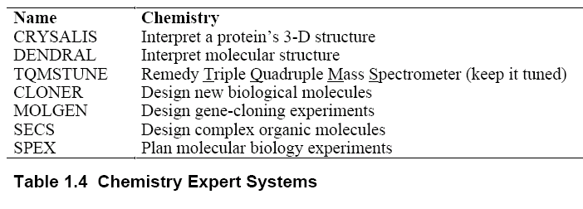

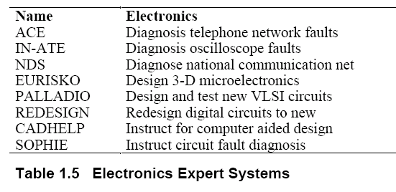

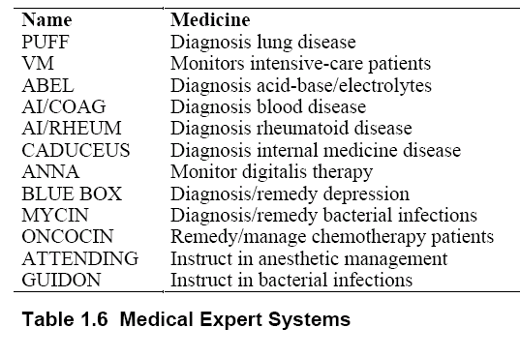

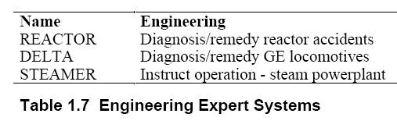

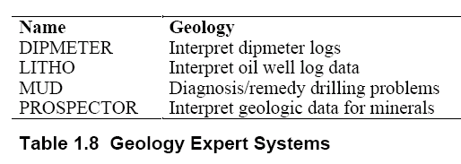

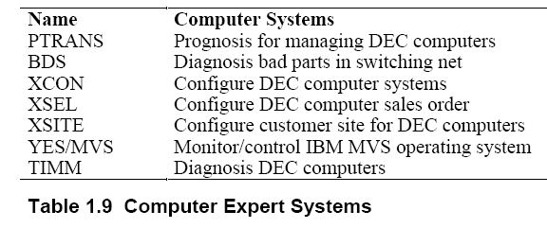

# Part 2 – Continue Working on your Mini-Project

Identify one or two group members to work with (this could be your lab group if you have already been working on lab exercises within a group).

After you identify the topic of your **mini-project**, you should continue working on it. Please keep in mind the **deadline** of the project.

# References

Some references to kick start your research with:

1. New research on expert systems: [Expert Systems | AITopics](https://aitopics.org/search?field=taxnodes&filters=taxnodes:Technology%7CInformation%20Technology%7CArtificial%20Intelligence%7CRepresentation%20%26%20Reasoning%40%40taxnodes:%22Technology%7CInformation%20Technology%7CArtificial%20Intelligence%7CRepresentation%20%26%20Reasoning%7CExpert%20Systems%22%40%40store:Classics)
2. K. Darlington, The Essence of Expert Systems, Prentice-Hall, Essex, England (2000).
3. E. Coakes and K. Merchant, Expert systems: a survey of their use in UK business, Information and Management 30 (1996) (5), pp. 223–230. (DOI: [10.1016/S0378-7206(96)01054-3](https://doi.org/10.1016/S0378-7206(96)01054-3))
4. J.D. Durkin, Expert systems: a view of the field, IEEE Expert 11 (1996) (2), pp. 56–63. (**DOI:**[10.1109/64.491282](https://doi.org/10.1109/64.491282))
5. P. Cortez, S. Moro, P. Rita, D. King, and J. Hall, “Insights from a text mining survey on Expert Systems research from 2000 to 2016,” *Expert Systems*, vol. 35, no. 3, p. e12280, 2018. (DOI: [10.1111/exsy.12280](https://doi.org/10.1111/exsy.12280))

# 